Private Sector Involvement through B2B Events
Good Practice by ENHANCER
Project Name: Enhancement of Entrepreneurship Capacities for Sustainable Socio-Economic Integration (ENHANCER) Project
Duration: 1 January 2020 – 31 December 2023
Budget: € 32,502,249.00
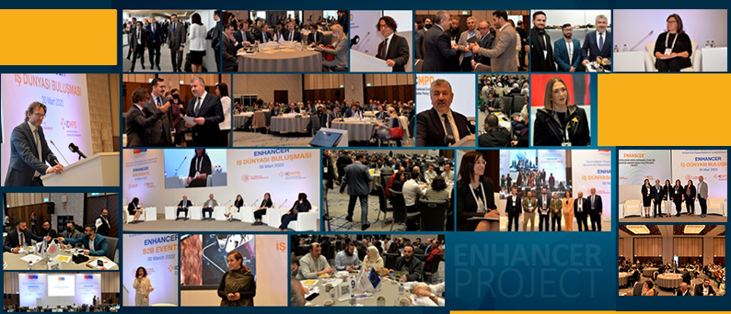

Private sector involvement plays an increasingly influential role in supporting economic inclusion and achieving development goals in migration related processes. In addition to offering jobs and training, businesses can also provide goods and technology that facilitate migrants’ access to the labor force and serve to enhance socio-economic integration.
Along these lines, since March 2020, ICMPD Turkey implements “Enhancement of Entrepreneurship Capacities for Sustainable Socio-Economic Integration (ENHANCER) Project” which crowns private sector involvement for socio-economic integration of Syrians under Temporary Protection in Turkey.
ENHANCER is funded by the European Union and implemented by ICMPD in coordination with the Directorate General of Development Agencies under the Ministry of Industry and Technology of the Republic of Türkiye.
Target Groups
- Potential and existing entrepreneurs among the Syrians under Temporary Protection (SuTP) and Local Host Communities (LHC)
- National level institutions related to entrepreneurship, development, migration policy and implementation,
- Local institutions which provide services to entrepreneurs,
- SMEs and cooperatives which have potential to create new job and livelihood opportunities.

Alongside various other activities ranging from entrepreneurship trainings, mentorship and grant programs that aim to strengthen the entrepreneurship ecosystem as a powerful driver of economic growth and job creation in Turkey, ENHANCER extends business growth opportunities of entrepreneurs and companies by improving business linkages through large sectoral B2B Events directed at private sector.

ENHANCER targets are to bring together 1200 SuTP and LHC entrepreneurs/companies in B2B Events which will lead to a minimum of 300 B2B Transactions defined as
- Business and financial transactions such as sales, strategic alliances between businesses, joint business creation
- Technical transactions in the form of meetings, visits, sharing of sample products or detailed product/business specifications, etc.
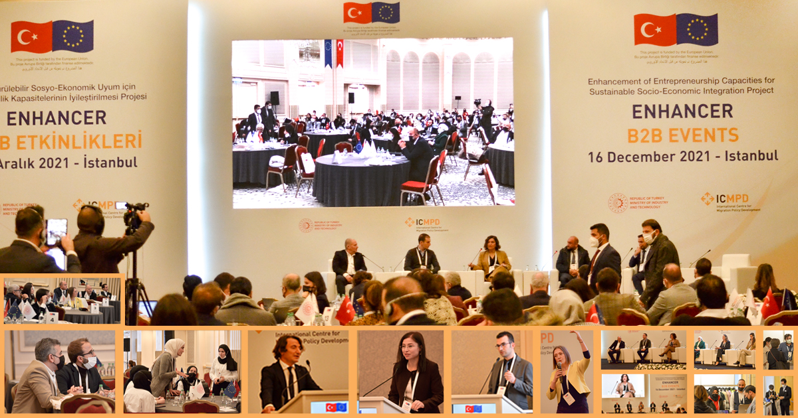
- Further support by third parties such as mentoring, promotion of the business or the products, incubation services, etc.

So far, ENHANCER has physically brought together approximately 400 SuTP and LHC entrepreneurs/companies in large venues with the following design:
- Inspirational Speakers from each sector including highly popular celebrities
- Awareness Raising Panels with the major players of each sector on hot topics of the sector
- Matching Table Session where all participants sit at round tables and conduct speed-networking based on their business needs
- Company Booths at the venue to present products

To reach the major players of each sector and inspirational speakers, Project Team actively worked with Short Term Experts from the private sector and gate keepers from the migrant business community. Hence, not only event implementation, but the preparation stage was also planned and conducted with the insight of private sector players.

To directly respond to the needs of SuTP and LHC entrepreneurs and companies in terms of business networking, ENHANCER Project Team devised online registration forms consisting of detailed questions on the entrepreneurs/companies’ expectations from a B2B event. Thus, registration forms did not only serve the purpose of data collection but facilitated the success of the matching session with a carefully edited seating plan for companies based on their specific business needs. Participants chose among the business needs listed below while filling out the form:

- Looking for new markets for export
- Would like to invest
- Looking for raw materials
- Looking for processor /subcontractor/sub manufacturer
- Would like to sell product
- Would like to offer creative/technological solutions
- Would like to expand my domestic market
- Would like to invest for my firm
- I sell raw materials
- Would like to be a contract manufacturer
- Would like to buy product
- Would like to receive creative / technological solutions

Each matching table was led by a moderator from the private sector; specifically, the panel members representing the large companies and short-term experts involved in the event. A translator of Turkish and Arabic was responsible of each table where 8-10 companies were seated.
Overall;
- The chances of meeting face-to-face the key players of each sector at matching tables,
- Presenting products at the booths to the large buyers and
- Listening to the panels with hot topics of the day
have become the major points of attraction in these events. The event was supported by simultaneous interpretation of Arabic and Turkish.
Some of the sector giants which repetitively joined ENHANCER B2B Events were Migros and BİM (leading Turkish food retailers), LCW (textile), each with over 1 billion USD turnover FLO (shoe), Hepsiburada and Trendyol (large online retailers) with each over 500 million USD turnover.

Date | Location | Targeted Sectors
16 December 2021 | İstanbul | - Textile and ready garment  - Food  - Innovative and high-tech value chains
30 March 2022 | İstanbul | - Textile and ready garment  - Food  - Shoemaking  - Innovative and high-tech value chains
21 June 2022 | Gaziantep | - Shoemaking

ENHANCER Sectors
- Textile and ready garment
- Furniture
- Agriculture/food
- Shoemaking
- Innovative and high-tech value chains (Software, design, e-commerce, etc.)
- Machinery and equipment and metal manufacturing and repair

