GOOD PRACTICES

BY ENHANCER
ENHANCER B2B Meetings

Since March 2020, ICMPD Turkey implements the “Enhancement of Entrepreneurship Capacities for Sustainable Socio-Economic Integration (ENHANCER) Project,” which boosts private sector involvement for the socio-economic integration of Syrians under Temporary Protection in Türkiye.

Private sector involvement plays an increasingly influential role in supporting economic inclusion and achieving development goals in migration-related processes. In addition to offering jobs and training, businesses can also provide goods and technology that facilitate migrants’ access to the labor force and serve to enhance socio-economic integration.
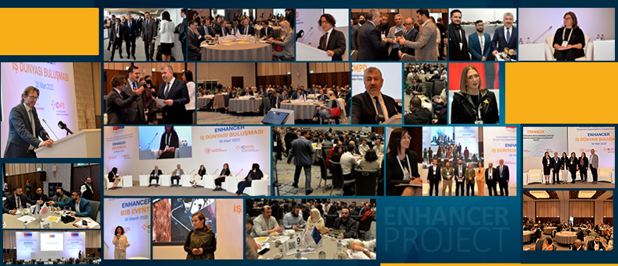

Alongside various other activities ranging from entrepreneurship trainings, mentorship and grant programs that aim to strengthen the entrepreneurship ecosystem as a powerful driver of economic growth and job creation in Türkiye, ENHANCER extends business growth opportunities of entrepreneurs and companies by improving business linkages through large sectoral B2B Events directed at the private sector.

ENHANCER targets are to bring together 1200 SuTP and LHC entrepreneurs/companies in B2B Events which will lead to a minimum of 300 B2B Transactions defined as
- Business and financial transactions such as sales, strategic alliances between businesses, joint business creation
- Technical transactions in the form of meetings, visits, sharing of sample products or detailed product/business specifications, etc.
- Further support by third parties such as mentoring, promotion of the business or the products, incubation services, etc.

So far, ENHANCER has physically brought together approximately 400 SuTP and LHC entrepreneurs/companies in large venues with the following design:
- Inspirational Speakers from each sector including highly popular celebrities
- Awareness Raising Panels with the major players of each sector on hot topics of the sector
- Matching Table Session where all participants sit at round tables and conduct speed-networking based on their business needs
- Company Booths at the venue to present products
- Pitching Session for Start-ups which brings together entrepreneurs with investors and financing channels
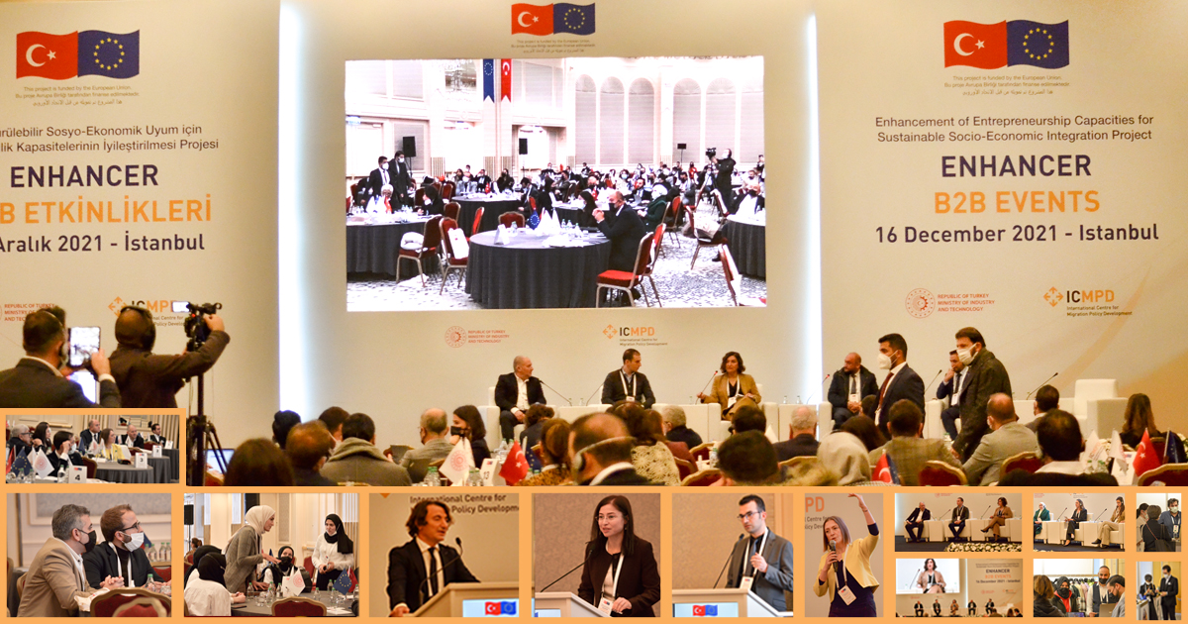

To reach the major players of each sector and inspirational speakers, Project Team actively worked with Short Term Experts from the private sector and stakeholders from the migrant business community. Hence, not only event implementation but the preparation stage was also planned and conducted with the insight of private sector players.

To directly respond to the needs of SuTP and LHC entrepreneurs and companies in terms of business networking, ENHANCER Project Team devised online registration forms consisting of detailed questions on the entrepreneurs’/companies’ expectations from a B2B event. Thus, registration forms not only serve the purpose of data collection but facilitated the success of the matching session with a carefully edited seating plan for companies based on their specific business needs.

Each matching table was led by a moderator from the private sector; specifically, the panel members representing the large companies and short-term experts involved in the event. A translator of Turkish and Arabic was responsible for each table where 8-10 companies were seated.
Overall, the chances of meeting face-to-face the key players of each sector at matching tables, presenting products at the booths to the large buyers, and listening to the panels with hot topics of the day have become the major points of attraction in these events. The event was supported by a simultaneous interpretation of Arabic and Turkish.
Target Sectors in ENHANCER Project are textile and ready garment, furniture, agriculture/food, shoemaking, innovative and high-tech value chains (Software, design, e-commerce, etc.), and machinery and equipment and metal manufacturing and repair.

First B2B Meeting- 16 December 2021, Istanbul

The first Business Networking Meeting within the scope of the ENHANCER Project was held in Istanbul Conrad Hotel on December 16, 2021. The event where Turkish and Syrian entrepreneurs in the textile and ready garment clothing, food, and innovative sectors that support them came together with the leading brands of the sector was successfully accomplished.

57 firm representatives took part in the event, which was organized with the aim of improving the opportunities for Turkish and Syrian entrepreneurs to work together, gain business development skills, and strengthens their business connections. Moreover, Syrian and Turkish start-ups had the opportunity to present their products in the booth area.

Second B2B Meeting- 30 March 2022, Istanbul

Companies with the highest turnover in their sectors in Türkiye participated in the March 30 B2B Meeting. The event provided an enabling platform for companies and enhanced the collaboration opportunities of Turkish and Syrian entrepreneurs while helping them acquire new business development skills and to strengthen their business network. In total, 237 participants and 128 companies participated to the event.
Matchings sessions tailored for the sectoral needs of Turkish and Syrian entrepreneurs and company representatives took place during the event.

The sessions focused on the investment opportunities, raw material, and product trade, domestic market, and export channels, and aimed to create new partnerships and solutions for the companies. During one-to-one and collective meetings, companies exchanged ideas and explored potential ways for collaboration.

The event also provided an opportunity for the start-ups to meet with investors in a pitching session where start-up representatives presented their business ideas to the members of the jury. Additionally, the leading companies met with potential providers and delivered their expectations and needs. ICMPD took an active role during the event to bolster the networking opportunities for all participants and ensured that companies were matched with their potential future partners during the event day.

Third B2B Meeting- 21 June 2022, Gaziantep

Third B2B Meeting was held at the GAPSHOES Fair on June 21, 2022. 77 firm representatives of shoemaking and innovative sectors that support the shoemaking sector came together at the B2B event held in Gaziantep on June 20-23, 2022, within the scope of the 33rd International Winter Fair of Shoes, Slippers, and Sub-Industry.

ENHANCER became a pioneer in its field thanks to the strong collaborations and organization of ICMPD. It was the first B2B Meeting organized within a fair. The event was very successful, considering that it was the first attempt.

In total, 59 companies opened booths, including 48 Turkish-owned and 11 SuTP-owned shoe firms in ENHANCER Pavilion. Moreover, a total of 7 Development Agencies and previous ENHANCER beneficiaries also opened booths. At the end of the event, there were 551 new business connections and 3 sales, 7 orders, 51 appointments were already made and 29 samples were given.

June 8 - Startup and Investor Meeting

ENHANCER project brought Turkish and Syrian entrepreneurs with investors and financing channels and provided information on their access to alternative finance. At the event, 20 selected start-ups made presentations to investors. A total of 6 start-ups were awarded in the categories of presentation performance, persuasion, innovation, team, social impact, and investment potential.

In the event, which took place in 2 different rooms, the first, second, and third places from each room were entitled to receive awards. In this context, the winners received an award of 50 thousand TRY, the second prize of 30 thousand TRY, and the third prize of 20 thousand TRY. Since there was an equality in points for the second place in the first group; The second and third start-ups received 25 thousand TRY.

Overall, the event was very well organized, containing a lot of different aspects of the startup ecosystem. Turkish and Syrian entrepreneurs had access to investors and alternative sources mechanisms. Panelists transferred knowledge and experience to new entrepreneurs.

General Entrepreneurship Training
by ENHANCER

General Entrepreneurship Trainings for 2500 Trainees from 11 provinces

The coronavirus disease, known as COVID-19, in 2020 coincided with the initiation of Project ENHANCER (Enhancement of Entrepreneurship Capacities for Sustainable Socio-Economic Integration) Project in Türkiye.

The ambitious aim of providing General Entrepreneurship Trainings to 2500 potential entrepreneurs from Syrian and Turkish communities in a period of 2 years seemed a hard mountain to climb given the closure measures. After long discussions on alternative routes, the final decision was to get on with the work with a result-oriented attitude instead of waiting for the lifting of Covid measures.

Since then, various inclusive tools and smart solutions deriving from a long list of lessons learned have served to turn the disadvantage of having to conduct these intensive trainings online to an advantage. Today, in December 2022, a total of 2694 Turkish citizens and Syrians under temporary protection have been certified and Entrepreneurship Trainings are becoming the face of ICMPD in Türkiye.

The aim of this blog post is to introduce the nuts and bolts of ENHANCER General Entrepreneurship Trainings that may represent a best practice for similar training with resembling target groups. Below are some of the methods and practices which may be replicable in other migrant-receiving contexts.

Design of Entrepreneurship Training Content

Instead of adopting entrepreneurship training existing in the market, Project Team worked with a group of academicians from Business Management and Law Faculties in Turkish universities and several Syrian entrepreneurs to create ENHANCER’s own training content to respond to the needs of the project’s target population.

To establish a tailored curriculum that will respond to the needs of Syrian trainees, a Learning Needs Survey was conducted with 1100 Syrians in Şanlıurfa, Gaziantep and Hatay. The project Team conducted regular meetings bringing together entrepreneurs with the module experts in order to strengthen the practical aspect of the training. The gender aspect of the training content was carefully designed with not only an academicperspective, but also with the contributions of a woman entrepreneur based in Istanbul.

Training Language

Since ENHANCER prioritizes social inclusion and classes consist of both Syrian and Turkish trainees, training language is a key aspect. All training slides contain both Arabic and Turkish on the same slide and trainings are conducted with simultaneous interpretation.

A major risk was a weak translation of entrepreneurship terminology to Arabic. Hence, once translated into Arabic, all training material- PowerPoint slides and lecture notes were edited by a Syrian entrepreneur with Business Management education.

All training staff, including assistants and interpreters, participated in the Training of Trainers based on the lecture notes and slides in order to learn the training content.

All training was monitored by an Arabic native-speaker expertwho held quick meetings with the interpreters on entrepreneurship terminology when needed.

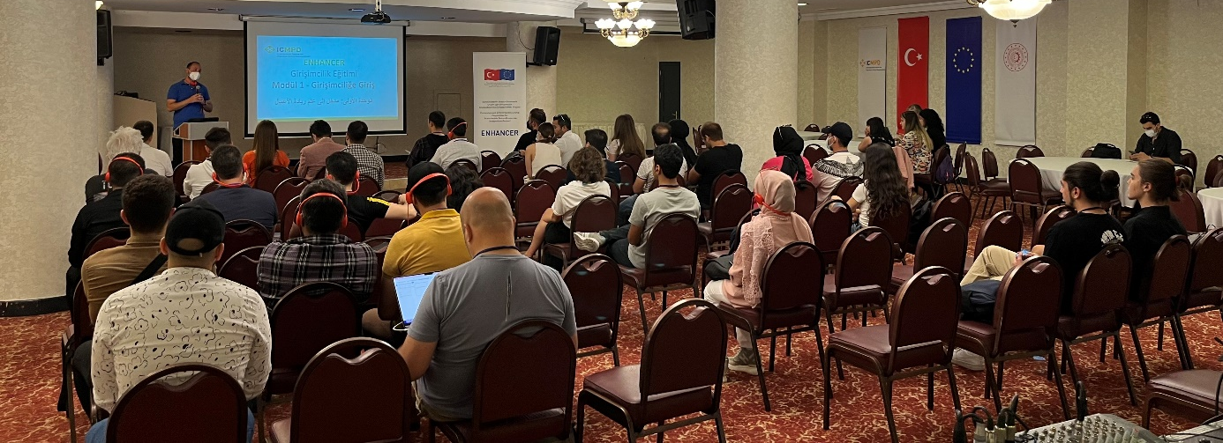

Key Points in Training delivery

With both Syrian and Turkish trainees in the same classes, difficulty in communication among classmates speaking different languages was a major barrier. Hence, Project Team added facilitators among the training staff, one facilitator for ten trainees, to take part in the group work, contribute to the creation of a collaborative learning environment and support the interactivity of the classes. Facilitators have the role of icebreakers in classes.

Successful Syrian or Turkish entrepreneurs were invited as guest speakers to each class to motivate, inspire, and inform trainees based on their own experiences. Women and Syrian entrepreneurs are especially prioritized for the training. .

Flexibility

In 2022, Project Team observed a decrease in interest in online training due to zoom fatigue in general. Thus, the training schedules were revised and face-to-face training was initiated in 11 provinces of Türkiye targeted by ENHANCER.

Currently, training applicants can select between online and face-to-face training. With the introduction of face-to-face training, the rate of applications had again increased.

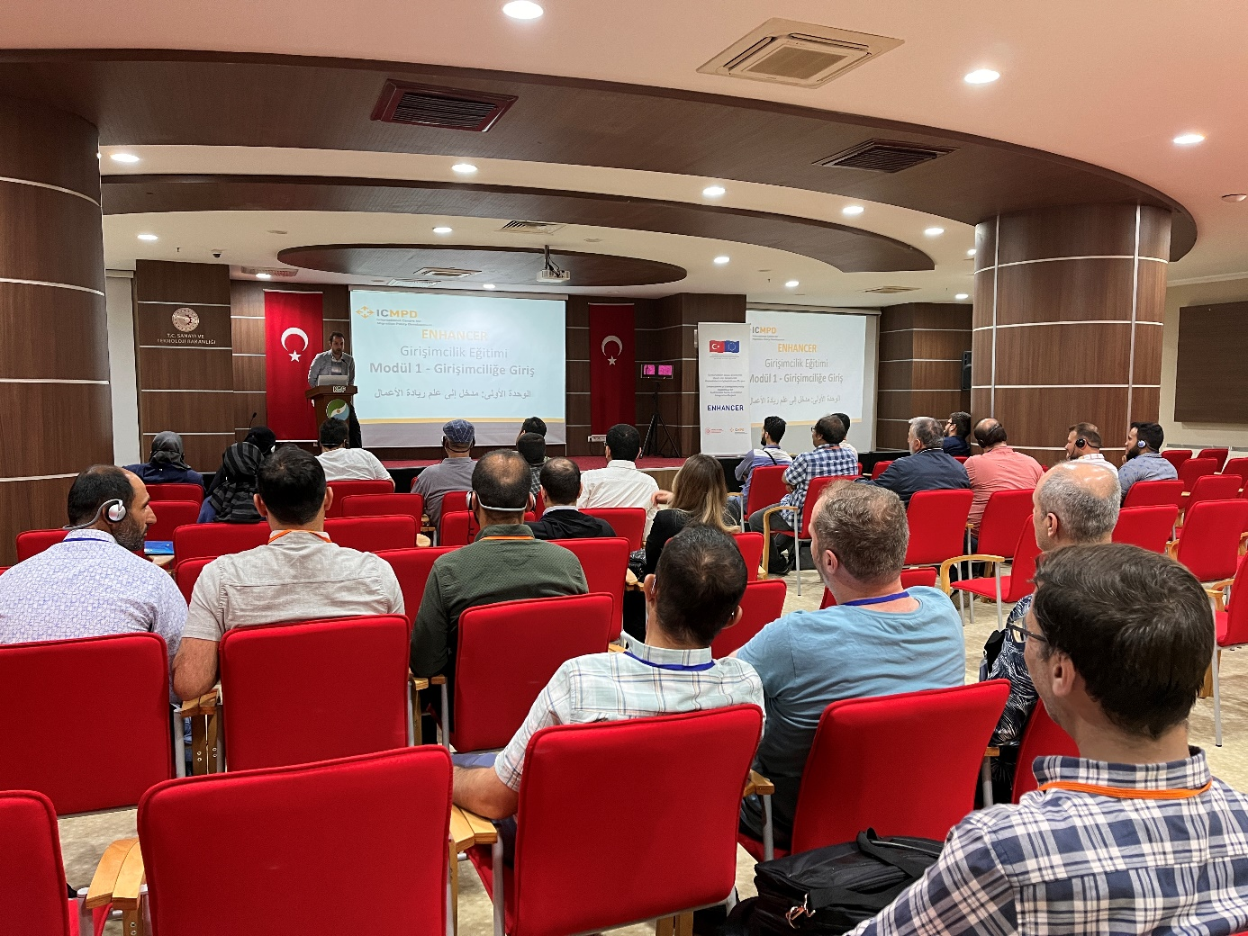

Accessibility

Apart from the entrepreneurship trainers who conduct the training, each component of ENHANCER Project Team takes part in the trainings with short presentations on their work. This involvement supports the community orientation of ENHANCER beneficiaries, as trainees can directly ask Project Staff questions on ICMPD and other project activities.

The project team has a separate e-mail address for trainings, only provided to training participants, and where both Turkish and Arabic e-mails are quickly replied. This serves accessibility of the Project Team and leads to open and frequent communication with trainees and Project Team.

Training Duration and Agenda

The duration of General Entrepreneurship Training is 24 hours, provided in various time arrangements, including work hours, weekends, during the day time or in the evenings. Applicants are asked about their time preference in the application form and if selected, they are placed in a class according to their preferences.

The training curriculum consists of modules on Introduction to Entrepreneurship, Innovative Entrepreneurship, Creative Thinking, Team Building, Marketing Communications and Customer Relations, Basic Accounting for Accountants, Finance, SWOT and Canvas, Legal Infrastructure of Entrepreneurship and Establishing a Firm and finally, Pitching and Presentation Skills.

Certification

For a participant to be certified in General Entrepreneurship Trainings,

- the trainee has to be present in a minimum of 75% of the training
- the trainee should fill in pre and post-tests
- the trainee should provide related ID documents

Monitoring and Data Collection

- Each class is visited by Project Staff and/or a Short Term Expert who fills in a standard Training Monitor Report.
- Trainees fill in an Evaluation Form which is available in both Turkish and Arabic.
- Training Monitor Reports and Evaluation forms serve to find areas of potential improvement in training.
- Project Team uses the online Learning Management System (LMS) to administer the training processes, ranging from the application, selection, maintenance of ID documents, pre and post-tests, and certification.
- LMS, as a digital learning and data maintenance environment, facilitates the distribution and management of ENHANCER’s training content and includes all aspects and materials of the trainings, keeps the content centralized in a single source and allows easy tracking and reporting.

Measuring the outcome

Apart from certification rates, ENHANCER expects an increase in the knowledge of participants and calculates this increase for every certified trainee. Pre and post tests measure the increase in knowledge in areas of Concept of innovation, Accounting, Branding, Customer relations, Investment capital, Business model, and legal structures to start a business. For training to be successful, the increase in knowledge should not fall below 20%.

Road Ahead

General Entrepreneurship Training certified 2500 participants and in 2023, Project Team will start Technical Entrepreneurship Training and certify 2500 trainees interested in market and sector-specific entrepreneurship trainings.

